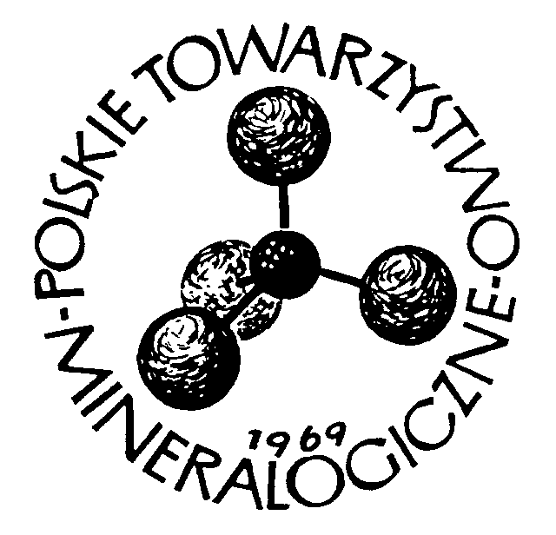place................................ date, ................

To the Board of
Mineralogical Society of Poland
30-059 Kraków, al. Mickiewicza 30

MEMBERSHIP DECLARATION
Surname and Name
Title/degree
Affiliation

Corresponding address
(postal code)
e-mail address
I declare my intention to join the Mineralogical Society of Poland and acknowledge the provisions of the Society's statute. I undertake to pay the admission fee in the amount of 40 PLN and I commit to regularly paying the annual membership fee in the amount of 150 PLN (rates valid from 15.04.2025).
Bank account number 92 1240 4559 1111 0000 5420 4162 in PKO S.A. bank

..........................................
(signature)

Nr of declaration............................... Date of receipt ..................................

Decision of the Main Board:
President ...................................................

Secretary ....................................................

